457.557 Water Resources Systems Engineering, Spring 2022
Assignment #2
Due before the lecture of Apr-19, 2022

- Solve and attach your solving procedures on the following problems on the textbook:
  - 4.1 (a), (b), (c), & (d)- Engineering economics
  - 4.9 (a) & (b)- Lagrange multiplier
  - 4.15- Dynamic programming (deterministic)
  - 4.18- Dynamic programming

- Solve the following LP Problem in Excel and in R:
$$Maximize Z = 10x_{1} + 8x_{2} + 9x_{3}$$
$$Subject to: 2x_{1} + 3x_{2} +x_{3} <= 1000$$
$$5x_{1} +6x_{2}+6x_{3} <=2400$$
$$x_{1}+x_{2}+x_{3} <=700$$
$$x_{1} >=0, x_{2} >= 160, x_{3}>=0$$
  - Attach your R code.
  - Compare your results obtained from Excel and R. Are they identical?

- Solve the following DP problem in R:
The inflows to a reservoir having a total capacity of four units of water are 1, 2, 1, and 2 units, respectively, for the four seasons in a year. For convenience, the amount of water is counted only be integer units of water. Thereby, the releases from the reservoir for water supply to a city and farms are sold for $2000 for the first unit of release, $1500 for the second unit, $1000 for the third unit, and $500 for the fourth unit. When the reservoir is full and spills one unit of water, a minor flood with result in a damage of $1500. When the spill reaches 2 units, a major flood will result in a damage of $4000. Determine the operation policy for maximum annual returns by dynamic programming using a backward algorithm, considering any amount of storage at the end of the year.
  - First, set the benefit function of your problem. How would you set your benefit function?
  - What is the governing equation of your problem?
  - What is the DP backward recursive equation for this example? Your equations should be different for seasons 1-3, and season 4.
  - Solve your problem in R. You may solve your problem first using Excel first.
  - Assume that the starting storage (S0, before Stage 1) is 4. What are the optimal release decisions during the four seasons? There should be multiple optimal release decisions. Name all and compute each path’s annual return values.

- In R, replicate the reservoir model on Boryeong Dam by you built on Assignment #1 with actual zone-based hedging rules provided below:
순 | 관심 | 주의 | 경계 | 심각
1.10일 | 43.9 | 39.9 | 30.1 | 16
1.20일 | 42.4 | 38.3 | 28.4 | 15.1
1.31일 | 40.8 | 37.2 | 26.8 | 14.1
2.10일 | 39.5 | 35.5 | 25.3 | 13.2
2.20일 | 38 | 34.4 | 24.7 | 12.4
2.28일 | 37 | 32.9 | 23.8 | 11.8
3.10일 | 36 | 31.9 | 22.9 | 11.7
3.20일 | 35 | 31.5 | 22.3 | 11.5
3.31일 | 34.5 | 30.5 | 21.7 | 11.3
4.10일 | 34.4 | 30.2 | 21.2 | 11.3
4.20일 | 34.2 | 30 | 21.1 | 11.1
4.30일 | 34.1 | 30.3 | 20.4 | 10.9
5.10일 | 34.1 | 30.3 | 19.9 | 10.6
5.20일 | 34.3 | 30.4 | 18.9 | 10.3
5.31일 | 34.2 | 30.4 | 18.4 | 10.3
6.10일 | 34.5 | 30.3 | 17.8 | 10.2
6.20일 | 35.3 | 29.6 | 16.4 | 9.2
6.30일 | 38.2 | 29.5 | 15.1 | 9
7.10일 | 43.3 | 30.5 | 14.7 | 9
7.20일 | 48 | 35.8 | 17.4 | 8.6
7.31일 | 52.7 | 40.8 | 23.2 | 9.6
8.10일 | 56.8 | 45.1 | 29.6 | 12.9
8.20일 | 59.7 | 50.3 | 33.6 | 15.2
8.31일 | 61.6 | 53.4 | 38.7 | 17.1
9.10일 | 62.6 | 54.6 | 40.8 | 18.4
9.20일 | 62.6 | 55.2 | 41.2 | 19.9
9.30일 | 61.9 | 55.5 | 41.9 | 21.2
10.10일 | 60.7 | 55.6 | 42.6 | 22.3
10.20일 | 59.1 | 54.5 | 42.6 | 22.3
10.31일 | 57 | 53 | 41.3 | 22.1
11.10일 | 55.1 | 51 | 39.5 | 21.4
11.20일 | 53.2 | 49.1 | 37.7 | 20.4
11.30일 | 51.3 | 47.2 | 36.3 | 19.4
12.10일 | 49.3 | 45.3 | 34.9 | 18.5
12.20일 | 47.6 | 43.5 | 33.4 | 17.7
12.31일 | 45.7 | 41.6 | 31.3 | 16.8

%다목적댐의 대응단계별 용수공급 조정기준
◦ 평상시 : 「수계별 댐과 보 등의 연계운영계획」 및 「댐 운영계획」을 준수하는 범위에서 수요량 이상으로 탄력 공급 가능
◦ 관심단계 : 수요량만큼 공급
※ (수요량) 하천유지용수 배분량 + 농업용수 배분량 + 생활･공업용수 계약량
◦ 주의단계 : 하천유지용수 배분량은 최대 100%까지 감량하고, 농업용수와 생활･공업용수는 실사용량만큼만 공급
※ (실사용량) 농업용수 배분량 또는 생활･공업용수 계약량 중 실제로 사용하는 양
◦ 경계단계 : 농업용수 실사용량 중 4월에서 6월은 20%, 7월에서 9월은 30%를 추가 감량하여 공급
◦ 심각단계 : 생활･공업용수 실사용량의 20%를 추가 감량하여 공급
◦ 정상회복 : 모든 감량 조치를 해제하고, 수요량 이상으로 탄력 공급 가능
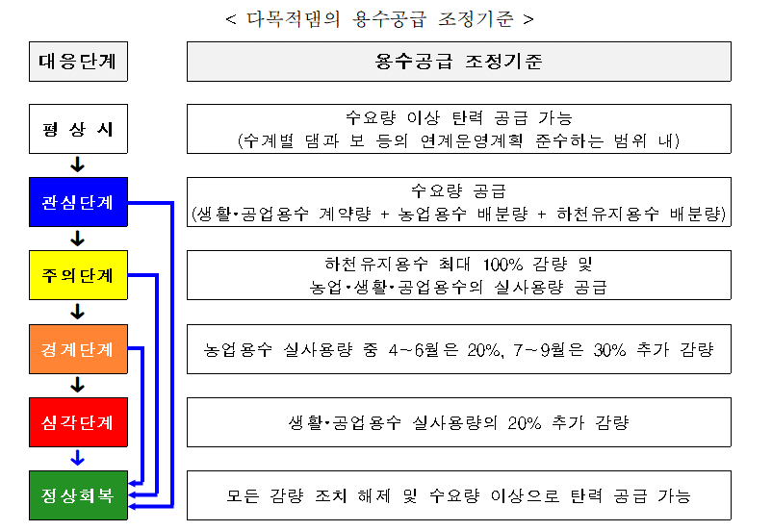

  - First, interpolate daily values with the provided values. You should use linear interpolation method in R. You do not have to include your interpolation results.
  - Assume that at the 탄력 공급 stage, water supply for M&I(생공용수) water is 3.0m3/s instead of 2.9m3/s. Conduct a reservoir simulation using the daily 용수공급조정기준 you interpolated in A. Your model should consider the maximum and minimum constraints.
  - Check if your model meets the annual mass balance equation (Total Inflow + Starting Storage = Total Actual Outflow + Final Storage). What is the sum of the left-hand side equation? Right-hand side of the equation? (They should be very much similar to each other)
  - Finally, compare your results with results from no hedging. What is the effect of hedging? Qualitatively? Quantitively?

